Geometric Construction

Definition
# Source: AI Source: Provided by: [Data Path: Persons Table -> ID Column: 1, Name_En Column: Motasem Essam] -> From: [ChatGPT] on [7/25/2026]
Geometric construction is the process of creating geometric figures, points, lines, angles, and other geometric objects using a specified set of geometric tools and exact mathematical procedures.
In classical Euclidean geometry, geometric construction is traditionally performed using only:
- Straightedge — used to draw a straight line through two known points.
- Compass — used to draw circles or arcs with a specified center and radius.
The goal is to construct a geometric object exactly, rather than approximately measuring or drawing it.
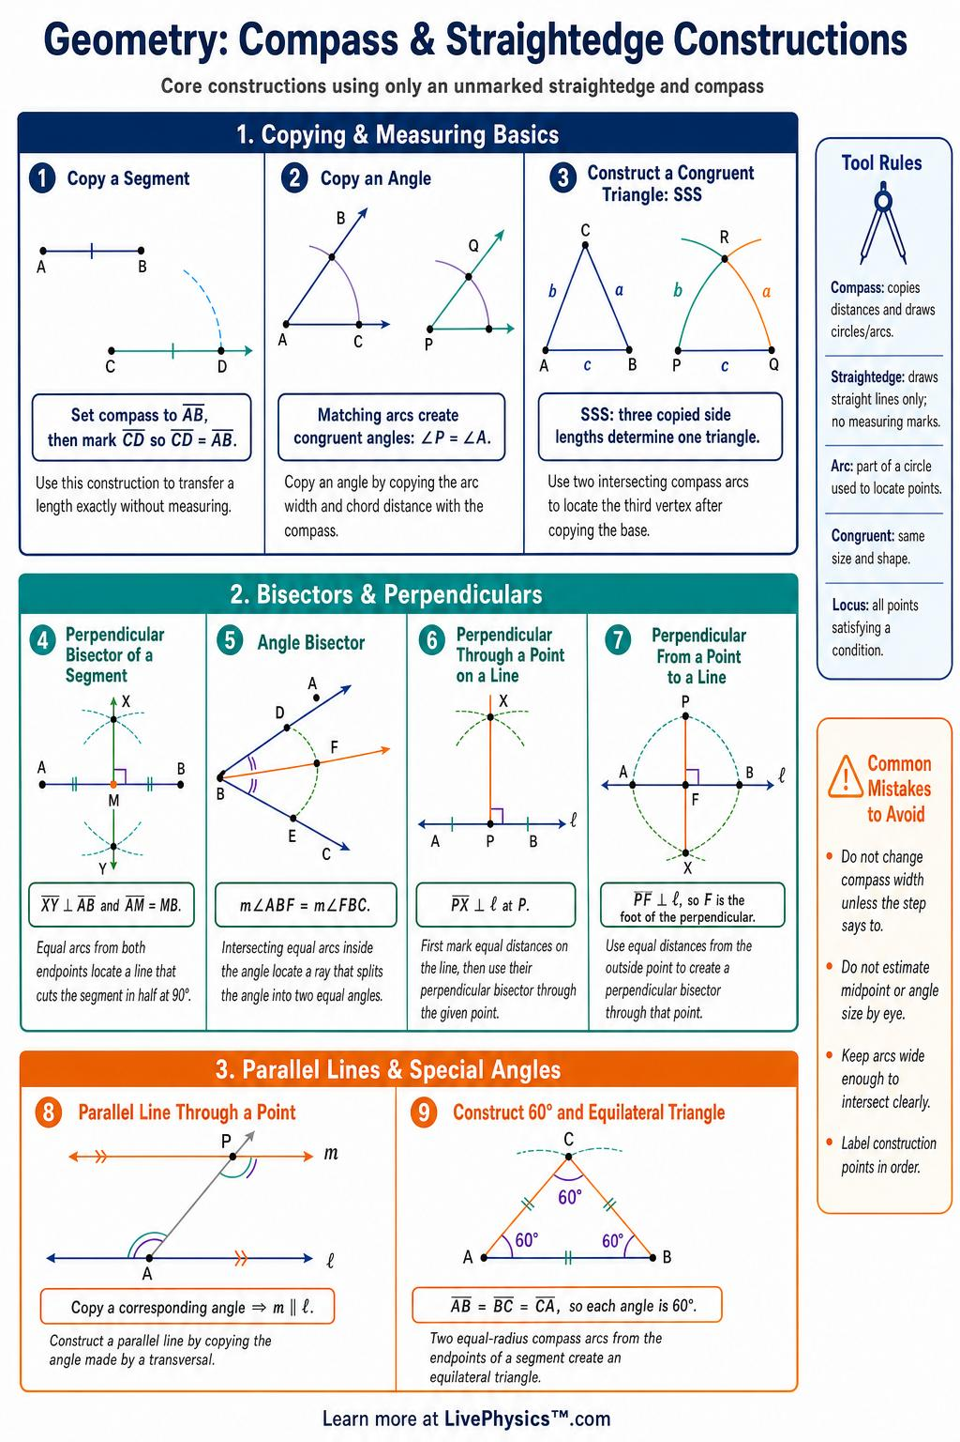
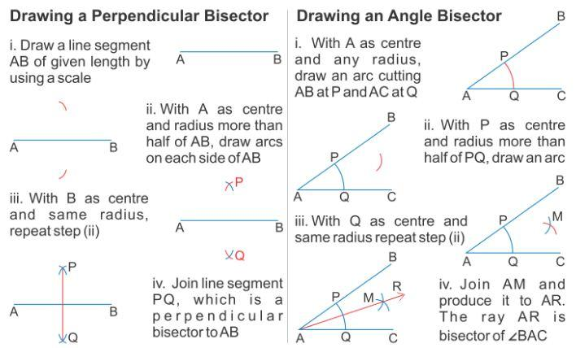
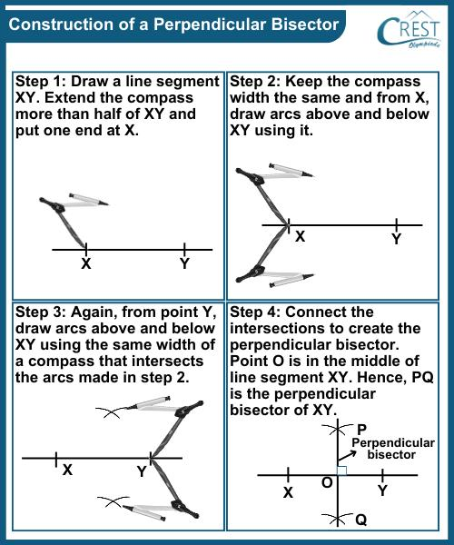
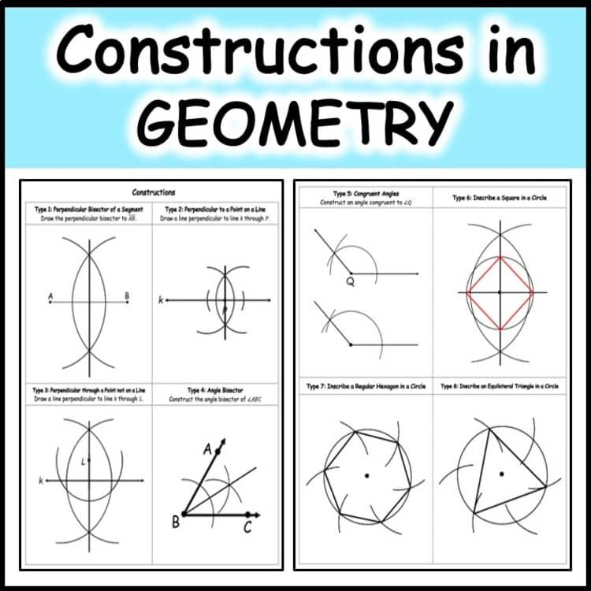
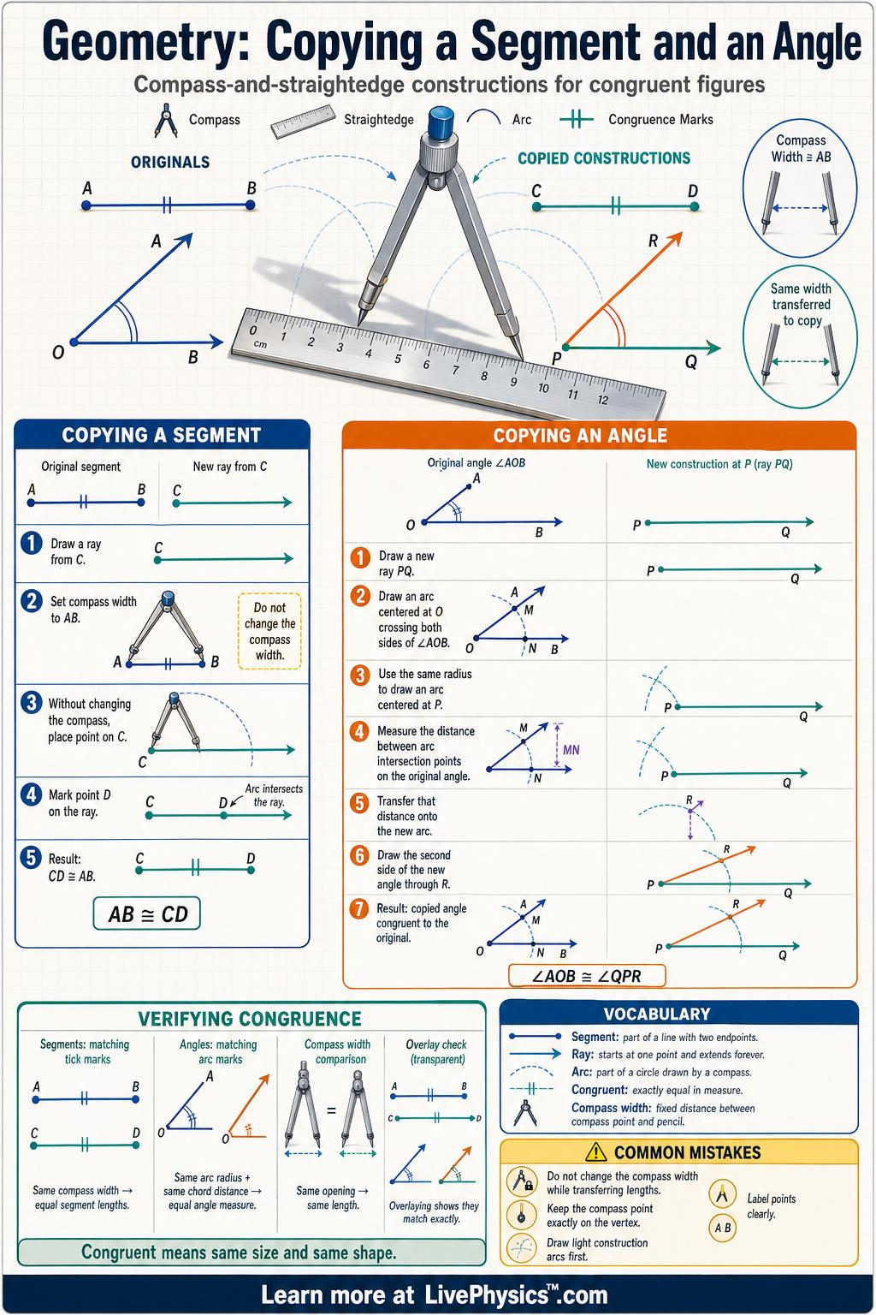

Fundamental Concept
# Source: AI Source: Provided by: [Data Path: Persons Table -> ID Column: 1, Name_En Column: Motasem Essam] -> From: [ChatGPT] on [7/25/2026]
A geometric construction begins with given geometric elements, such as:
- Points
- Line segments
- Lines
- Angles
- Circles
A sequence of exact construction steps is then used to create the required object.
For example, to construct the perpendicular bisector of a segment $\overset{‾}{AB}$:
- Open the compass to a radius greater than half of $AB$.
- Draw an arc centered at $A$.
- Without changing the compass width, draw an arc centered at $B$.
- Let the arcs intersect at $P$and $Q$.
- Draw line $\overset{↔}{PQ}$.
The resulting line is the perpendicular bisector of $\overset{‾}{AB}$.

Main Characteristics
# Source: AI Source: Provided by: [Data Path: Persons Table -> ID Column: 1, Name_En Column: Motasem Essam] -> From: [ChatGPT] on [7/25/2026]
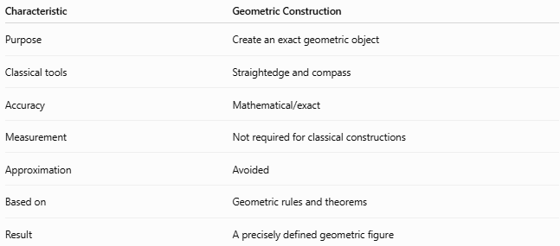
Characteristic | Geometric Construction
Purpose | Create an exact geometric object
Classical tools | Straightedge and compass
Accuracy | Mathematical/exact
Measurement | Not required for classical constructions
Approximation | Avoided
Based on | Geometric rules and theorems
Result | A precisely defined geometric figure

Basic Construction Tools

1. Straightedge
# Source: AI Source: Provided by: [Data Path: Persons Table -> ID Column: 1, Name_En Column: Motasem Essam] -> From: [ChatGPT] on [7/25/2026]
A straightedge is an unmarked ruler used to draw straight lines.
It is not traditionally used to measure distances.
Its main operation is:
$$\boxed{\text{Draw the line through two known points}}$$

2. Compass
# Source: AI Source: Provided by: [Data Path: Persons Table -> ID Column: 1, Name_En Column: Motasem Essam] -> From: [ChatGPT] on [7/25/2026]
A compass is used to construct circles and arcs.
Its main operation is:
$$\boxed{\text{Draw a circle centered at a known point with a chosen radius}}$$
A compass can also transfer a length from one location to another.

Basic Types of Geometric Construction

1. Constructing a Line Segment
# Source: AI Source: Provided by: [Data Path: Persons Table -> ID Column: 1, Name_En Column: Motasem Essam] -> From: [ChatGPT] on [7/25/2026]
A line segment can be constructed by joining two given points.
$$A∙⟶∙B$$
The resulting segment is:
$$\boxed{\overset{‾}{AB}}$$

2. Copying a Line Segment
# Source: AI Source: Provided by: [Data Path: Persons Table -> ID Column: 1, Name_En Column: Motasem Essam] -> From: [ChatGPT] on [7/25/2026]
A compass can be used to reproduce the exact length of a given segment.
If:
$$AB=L$$
then the copied segment satisfies:
$$\boxed{A^{'}B^{'}=AB}$$

3. Perpendicular Bisector
# Source: AI Source: Provided by: [Data Path: Persons Table -> ID Column: 1, Name_En Column: Motasem Essam] -> From: [ChatGPT] on [7/25/2026]
The perpendicular bisector of a segment passes through its midpoint and is perpendicular to the segment.
For $\overset{‾}{AB}$:
$$\boxed{MA=MB}$$
and:
$$\boxed{\overset{‾}{PM}⊥\overset{‾}{AB}}$$
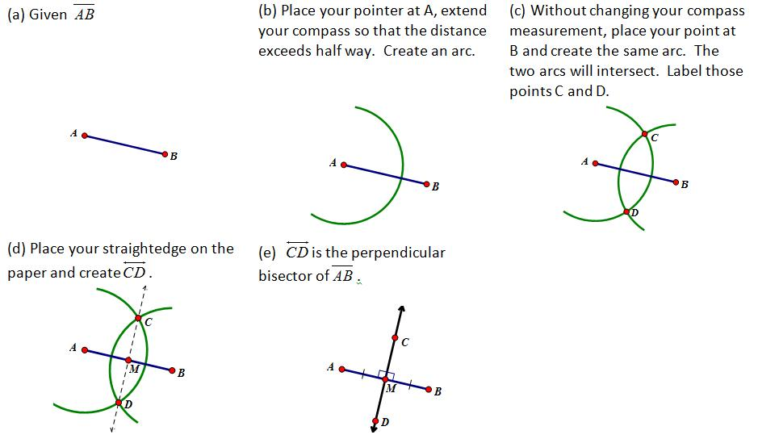
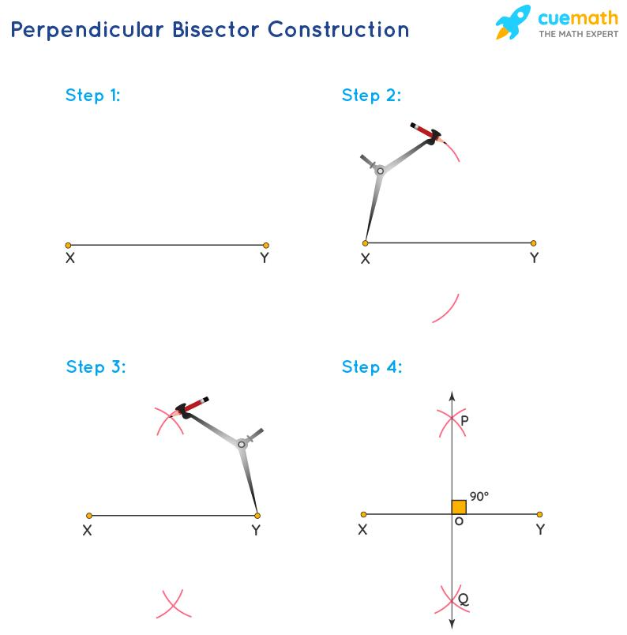
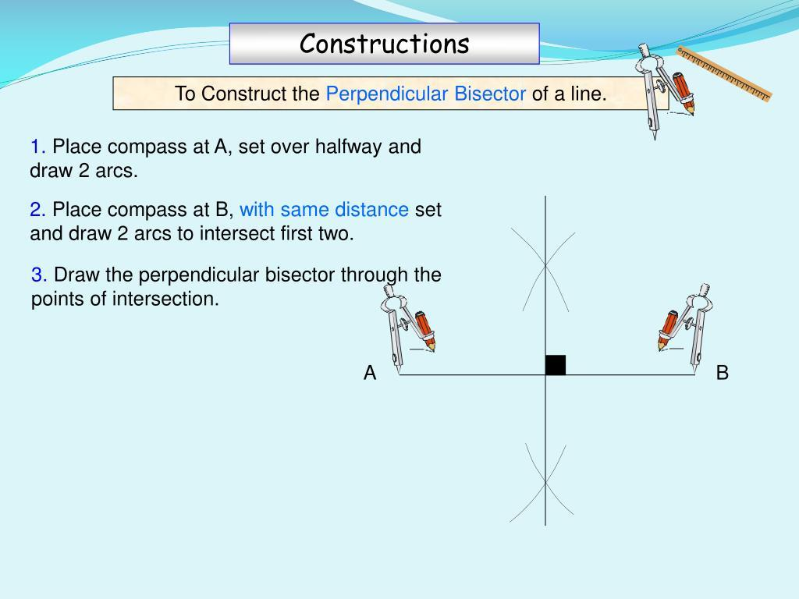
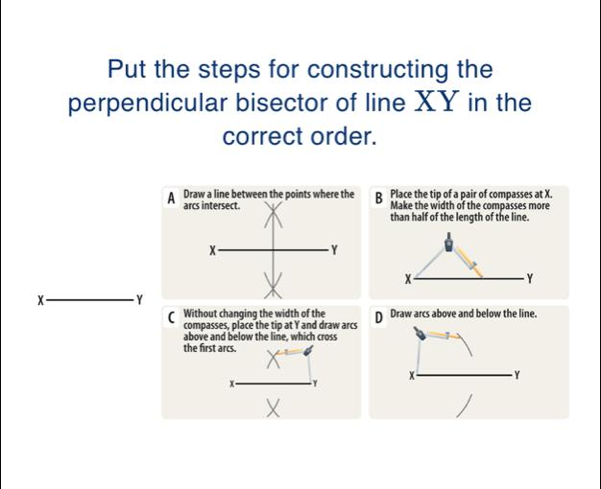
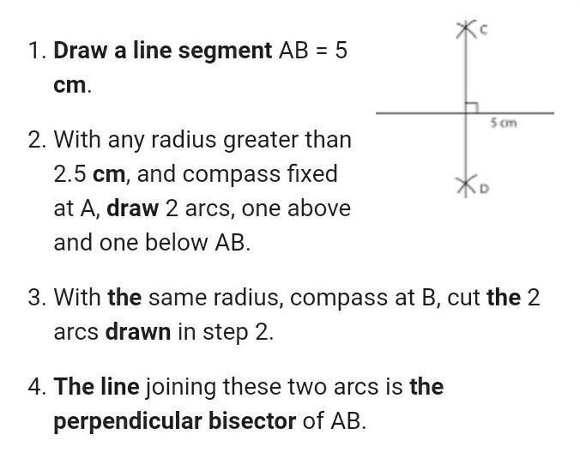
4. Angle Bisector
An angle bisector divides an angle into two congruent angles.
For $∠ABC$:
$$\boxed{∠ABD=∠DBC}$$
Therefore:
$$\boxed{∠ABC=2∠ABD}$$
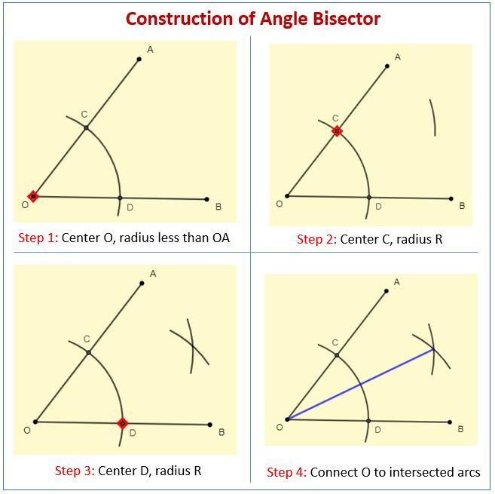
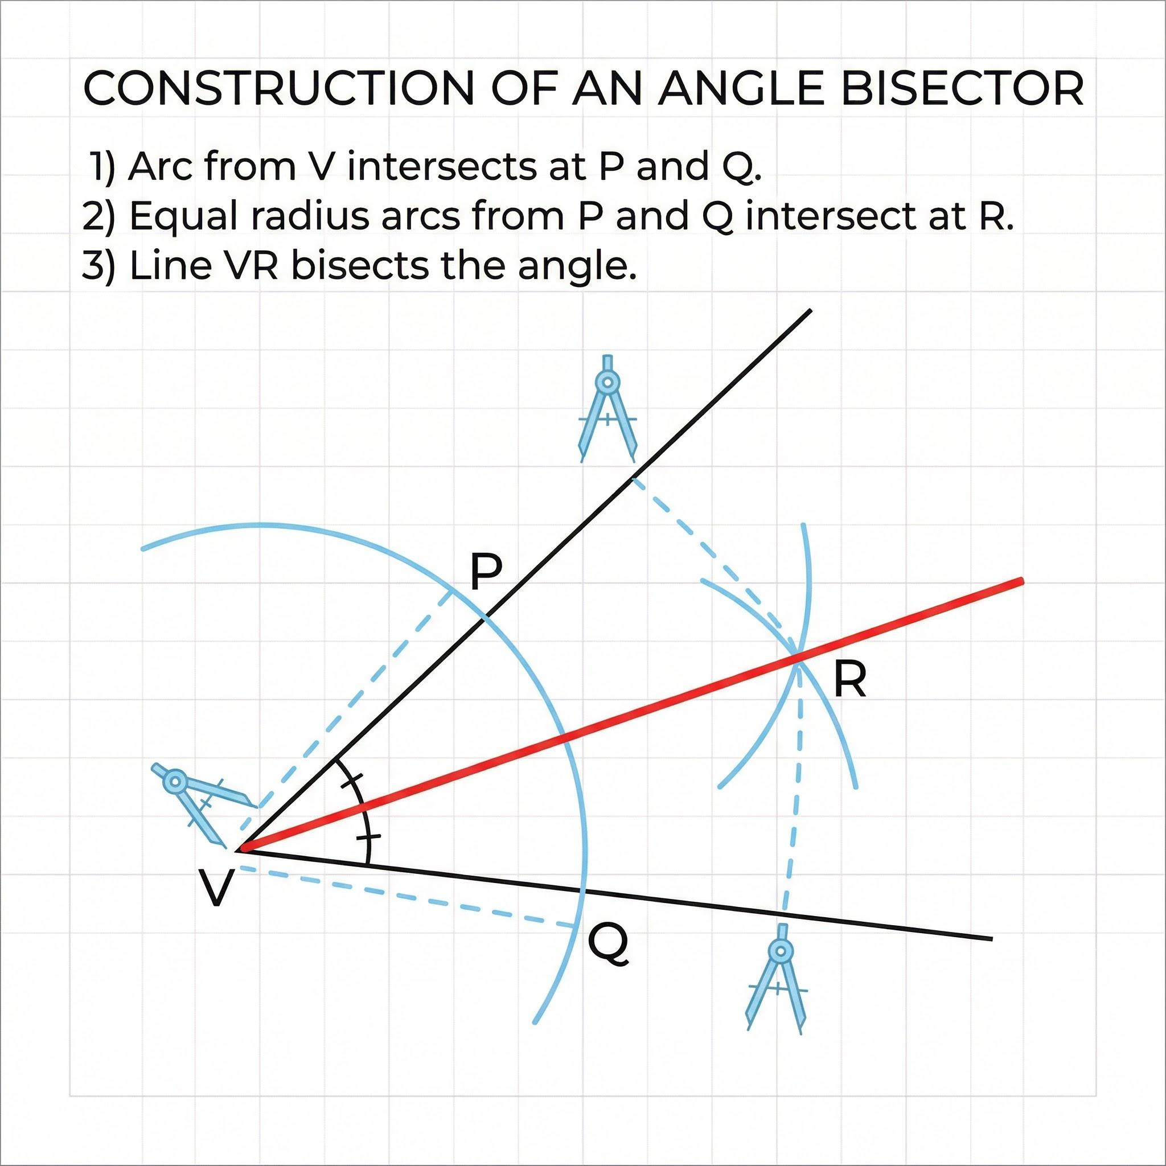
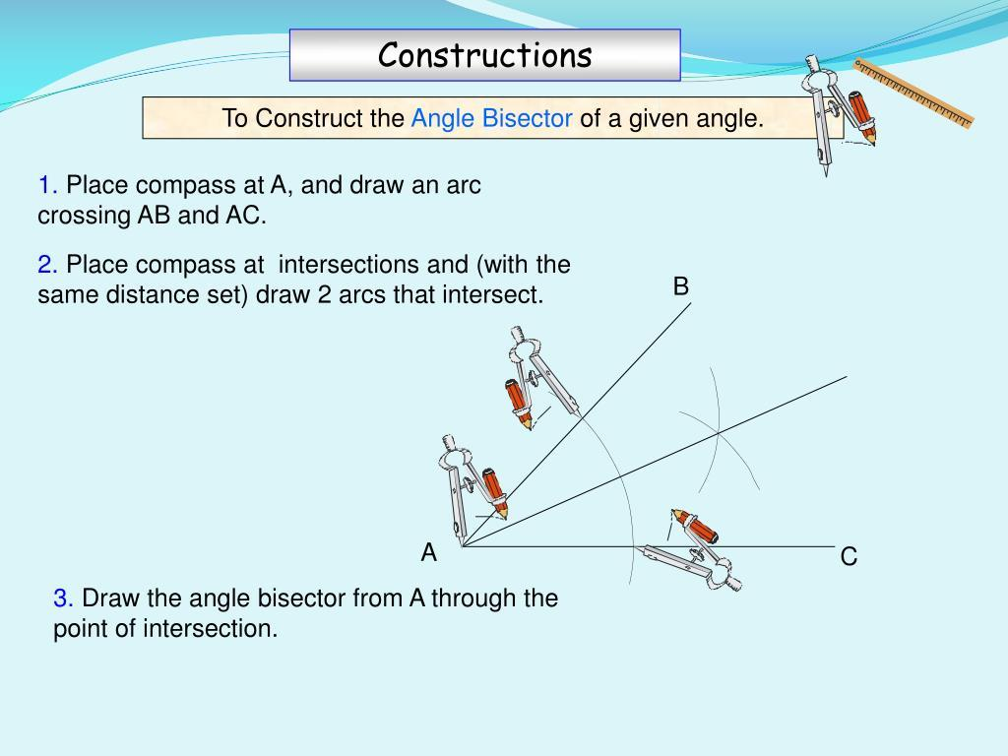
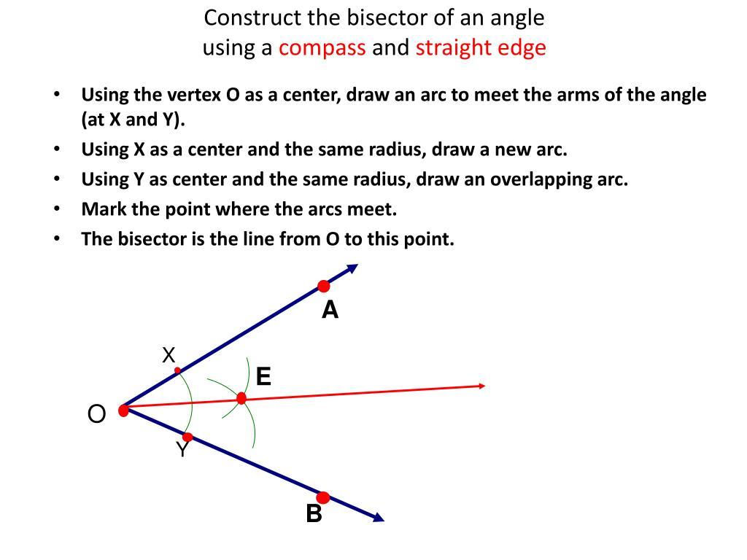
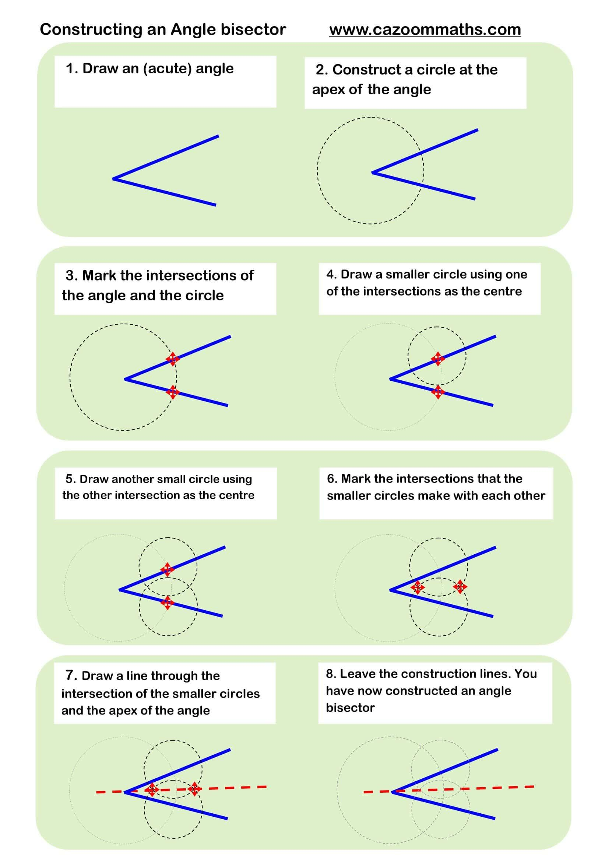

5. Constructing a Perpendicular Line
# Source: AI Source: Provided by: [Data Path: Persons Table -> ID Column: 1, Name_En Column: Motasem Essam] -> From: [ChatGPT] on [7/25/2026]
A perpendicular line forms a ${90}^{∘}$angle with another line.
$$\boxed{θ={90}^{∘}}$$
A compass and straightedge can construct a perpendicular through:
- A point on a line
- A point outside a line

6. Constructing a Parallel Line
# Source: AI Source: Provided by: [Data Path: Persons Table -> ID Column: 1, Name_En Column: Motasem Essam] -> From: [ChatGPT] on [7/25/2026]
A line parallel to a given line can be constructed using geometric methods such as copying an angle.
For parallel lines:
$$\boxed{l_{1}∥l_{2}}$$
Corresponding or alternate interior angles can be used to establish the parallel relationship.

7. Copying an Angle
# Source: AI Source: Provided by: [Data Path: Persons Table -> ID Column: 1, Name_En Column: Motasem Essam] -> From: [ChatGPT] on [7/25/2026]
A compass can reproduce the exact measure of a given angle.
If:
$$∠ABC=θ$$
then a copied angle satisfies:
$$\boxed{∠A^{'}B^{'}C^{'}=θ}$$

8. Constructing Special Angles
# Source: AI Source: Provided by: [Data Path: Persons Table -> ID Column: 1, Name_En Column: Motasem Essam] -> From: [ChatGPT] on [7/25/2026]
Classical constructions can produce several important angles, including:
$$\boxed{{30}^{∘}, {45}^{∘}, {60}^{∘}, {90}^{∘}}$$
Other angles can be constructed by combining or bisecting constructible angles.

Triangle Constructions
# Source: AI Source: Provided by: [Data Path: Persons Table -> ID Column: 1, Name_En Column: Motasem Essam] -> From: [ChatGPT] on [7/25/2026]
Triangles can be constructed when sufficient information is given.

1. SSS Construction
# Source: AI Source: Provided by: [Data Path: Persons Table -> ID Column: 1, Name_En Column: Motasem Essam] -> From: [ChatGPT] on [7/25/2026]
SSS — Side-Side-Side
Given three side lengths:
$$a, b, c$$
a triangle can be constructed if they satisfy the triangle inequality:
$$\boxed{a+b>c} \\ \boxed{a+c>b} \\ \boxed{b+c>a}$$

2. SAS Construction
# Source: AI Source: Provided by: [Data Path: Persons Table -> ID Column: 1, Name_En Column: Motasem Essam] -> From: [ChatGPT] on [7/25/2026]
SAS — Side-Angle-Side
Given:
- Two side lengths
- The included angle
the triangle can be constructed.

3. ASA Construction
# Source: AI Source: Provided by: [Data Path: Persons Table -> ID Column: 1, Name_En Column: Motasem Essam] -> From: [ChatGPT] on [7/25/2026]
ASA — Angle-Side-Angle
Given:
- Two angles
- The included side
the triangle can be constructed.

4. AAS Construction
# Source: AI Source: Provided by: [Data Path: Persons Table -> ID Column: 1, Name_En Column: Motasem Essam] -> From: [ChatGPT] on [7/25/2026]
AAS — Angle-Angle-Side
Given:
- Two angles
- A corresponding non-included side
the triangle can be constructed.

5. RHS Construction
# Source: AI Source: Provided by: [Data Path: Persons Table -> ID Column: 1, Name_En Column: Motasem Essam] -> From: [ChatGPT] on [7/25/2026]
RHS — Right angle-Hypotenuse-Side
For a right triangle, knowing:
- the right angle,
- the hypotenuse,
- one other side
is sufficient for construction.

Circle Constructions
# Source: AI Source: Provided by: [Data Path: Persons Table -> ID Column: 1, Name_En Column: Motasem Essam] -> From: [ChatGPT] on [7/25/2026]
Geometric construction can also be used to create important elements of circles.

Constructing a Circle
# Source: AI Source: Provided by: [Data Path: Persons Table -> ID Column: 1, Name_En Column: Motasem Essam] -> From: [ChatGPT] on [7/25/2026]
Given a center $O$and radius $r$:
$$\boxed{C\left(O , r\right)}$$
can be constructed using a compass.

Constructing a Circle Through Three Points
# Source: AI Source: Provided by: [Data Path: Persons Table -> ID Column: 1, Name_En Column: Motasem Essam] -> From: [ChatGPT] on [7/25/2026]
Given three non-collinear points:
$$A, B, C$$
the center can be found by constructing the perpendicular bisectors of two sides.
Their intersection gives the circumcenter:
$$\boxed{O}$$
Then construct:
$$\boxed{C\left(O , OA\right)}$$
This circle passes through $A$, $B$, and $C$.

Common Classical Constructions
# Source: AI Source: Provided by: [Data Path: Persons Table -> ID Column: 1, Name_En Column: Motasem Essam] -> From: [ChatGPT] on [7/25/2026]
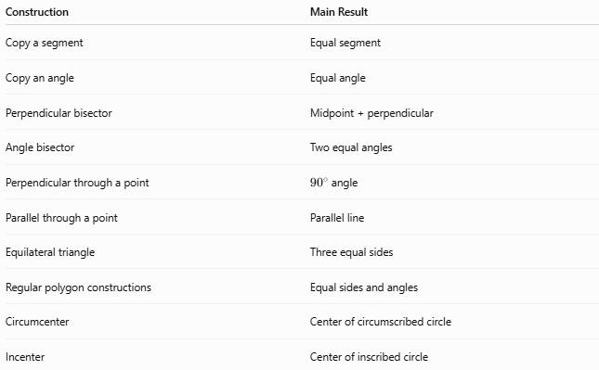
Construction | Main Result
Copy a segment | Equal segment
Copy an angle | Equal angle
Perpendicular bisector | Midpoint + perpendicular
Angle bisector | Two equal angles
Perpendicular through a point | ${90}^{∘}$angle
Parallel through a point | Parallel line
Equilateral triangle | Three equal sides
Regular polygon constructions | Equal sides and angles
Circumcenter | Center of circumscribed circle
Incenter | Center of inscribed circle

Constructible Figures
# Source: AI Source: Provided by: [Data Path: Persons Table -> ID Column: 1, Name_En Column: Motasem Essam] -> From: [ChatGPT] on [7/25/2026]
A figure is constructible if it can be obtained using the permitted construction operations.
Classical straightedge-and-compass constructions are closely related to numbers that can be obtained using arithmetic operations and square roots starting from rational quantities.
Examples of classically constructible objects include:
- Midpoints
- Perpendiculars
- Angle bisectors
- Equilateral triangles
- Regular polygons such as the regular $3$-, $4$-, $5$-, $6$-, and $8$-gons
- Square roots of constructible lengths

Construction vs Measurement
# Source: AI Source: Provided by: [Data Path: Persons Table -> ID Column: 1, Name_En Column: Motasem Essam] -> From: [ChatGPT] on [7/25/2026]
Geometric construction and measurement are different processes.
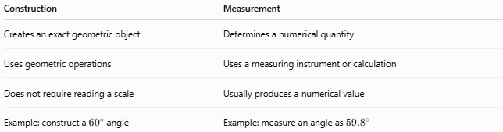
Construction | Measurement
Creates an exact geometric object | Determines a numerical quantity
Uses geometric operations | Uses a measuring instrument or calculation
Does not require reading a scale | Usually produces a numerical value
Example: construct a ${60}^{∘}$angle | Example: measure an angle as ${59.8}^{∘}$
For example, constructing a ${60}^{∘}$angle is different from drawing an angle that appears to measure ${60}^{∘}$.

Construction vs Drawing
# Source: AI Source: Provided by: [Data Path: Persons Table -> ID Column: 1, Name_En Column: Motasem Essam] -> From: [ChatGPT] on [7/25/2026]
A drawing may be approximate.
A construction must follow a sequence of mathematically justified operations.
For example:
Drawing a line that looks perpendicular is not necessarily a geometric construction.
Instead, a construction uses compass-and-straightedge operations that guarantee:
$$\boxed{l_{1}⊥l_{2}}$$

General Construction Process
# Source: AI Source: Provided by: [Data Path: Persons Table -> ID Column: 1, Name_En Column: Motasem Essam] -> From: [ChatGPT] on [7/25/2026]
A geometric construction can generally be organized as:
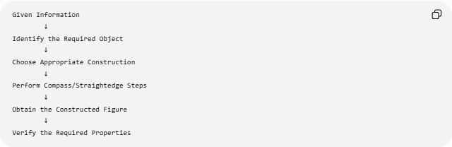
Given Information
↓
Identify the Required Object
↓
Choose Appropriate Construction
↓
Perform Compass/Straightedge Steps
↓
Obtain the Constructed Figure
↓
Verify the Required Properties

Construction and Proof
# Source: AI Source: Provided by: [Data Path: Persons Table -> ID Column: 1, Name_En Column: Motasem Essam] -> From: [ChatGPT] on [7/25/2026]
A geometric construction is often accompanied by a proof.
The construction establishes how the object is created.
The proof establishes why the construction produces the required object.
For example:
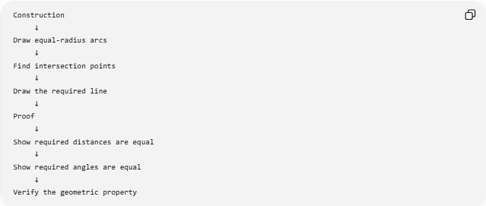
Construction
↓
Draw equal-radius arcs
↓
Find intersection points
↓
Draw the required line
↓
Proof
↓
Show required distances are equal
↓
Show required angles are equal
↓
Verify the geometric property
For a perpendicular bisector, the proof establishes:
$$PA=PB$$
and:
$$QA=QB$$
Therefore both $P$and $Q$lie on the locus of points equidistant from $A$and $B$, so:
$$\boxed{PQ\text{ is the perpendicular bisector of }AB}$$

Classification
# Source: AI Source: Provided by: [Data Path: Persons Table -> ID Column: 1, Name_En Column: Motasem Essam] -> From: [ChatGPT] on [7/25/2026]
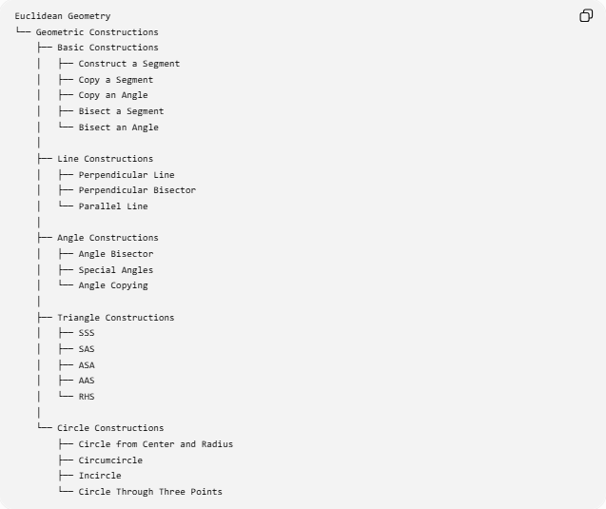
Euclidean Geometry
└── Geometric Constructions
├── Basic Constructions
│ ├── Construct a Segment
│ ├── Copy a Segment
│ ├── Copy an Angle
│ ├── Bisect a Segment
│ └── Bisect an Angle
│
├── Line Constructions
│ ├── Perpendicular Line
│ ├── Perpendicular Bisector
│ └── Parallel Line
│
├── Angle Constructions
│ ├── Angle Bisector
│ ├── Special Angles
│ └── Angle Copying
│
├── Triangle Constructions
│ ├── SSS
│ ├── SAS
│ ├── ASA
│ ├── AAS
│ └── RHS
│
└── Circle Constructions
├── Circle from Center and Radius
├── Circumcircle
├── Incircle
└── Circle Through Three Points

Key Points
# Source: AI Source: Provided by: [Data Path: Persons Table -> ID Column: 1, Name_En Column: Motasem Essam] -> From: [ChatGPT] on [7/25/2026]
- Geometric construction creates geometric objects through exact construction procedures.
- Classical constructions use a straightedge and compass.
- A straightedge draws straight lines but does not measure.
- A compass creates circles and arcs and transfers lengths.
- Common constructions include:
  - perpendicular bisectors,
  - angle bisectors,
  - perpendicular lines,
  - parallel lines,
  - copied segments,
  - copied angles,
  - triangles,
  - circles.
- Construction is different from approximate drawing and measurement.
- A construction is often followed by a mathematical proof.
- Triangle construction can be based on conditions such as SSS, SAS, ASA, AAS, and RHS.
- Constructibility concerns whether a geometric object can be obtained using the permitted construction operations.

Conclusion
# Source: AI Source: Provided by: [Data Path: Persons Table -> ID Column: 1, Name_En Column: Motasem Essam] -> From: [ChatGPT] on [7/25/2026]
Geometric construction is the exact creation of geometric objects using a defined set of geometric operations. In classical Euclidean geometry, the fundamental tools are the straightedge and compass. Constructions provide exact methods for creating lines, angles, triangles, circles, and important geometric relationships such as perpendicularity, parallelism, and bisection.
The central idea is:
$$\boxed{\text{Geometric Construction}=\text{Exact Geometric Creation by Defined Operations}}$$

